NUGGETS
FOR
CHRIST CHURCH, ST ANDREW’S AND ST MICHAEL’S

3RD OCTOBER 2026

Hello everyone!

This month, my image is a colour palette because I was thinking of asking the question – what colour would you paint peace? There are so many ways in which we can think of peace. It could be world peace – where countries and nations get along, where they are not at war within themselves or with one another. It could be peace and quiet on a still day – whether this is a calm weather day or an oasis in the middle of lots of busyness. It could be the peace that comes from making a decision over which you have spent time agonising. It could be the peace that we see, or long to see, within our families or communities. It could be the peace within ourselves. And all of these might seem a different colour. Or perhaps peace comes as a dove, a sign of God’s spirit and presence, as the peace that only God can give, that takes us to the heart of peace whatever the circumstances are around us and however we feel. ‘Peace, my peace, I give to you’, says Jesus. May you know God’s peace today and every day.

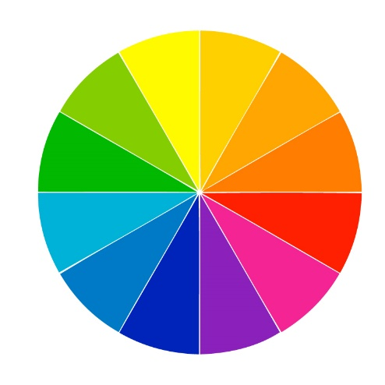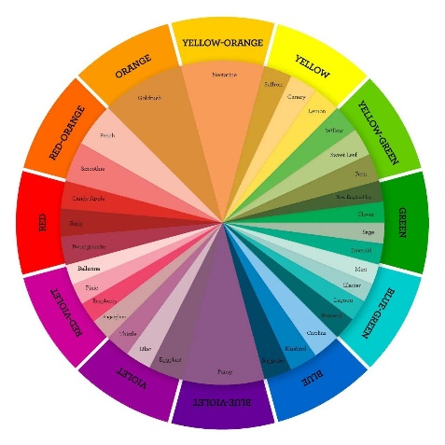

OCTOBER
Sunday 4th October 2026
St Michael’s
9.00am – Holy Communion

Christ Church
10.00am – Harvest Holy Communion

St Andrew’s
10.30am – Harvest Family Service

Coffee Connect at Christ Church
Coffee Connect meets on Friday 9th October from 2.00 to 4.00pm at Christ Church. Come along to meet others for a chat and enjoy homemade cakes and biscuits.

Concert at Christ Church
Hereward Harmony with others will be performing at Christ Church on Saturday 10th October at 7.30pm. Cost - £10.00 and tickets are available from David, Norman and Malcolm. Funds raised will go to Sue Ryder.

Sunday 11th October 2026
Christ Church
10.00am – Morning Worship

St Andrew’s
10.30am – Holy Communion

St Michael’s
5.00pm – Evening Prayer

Coffee Morning at St Andrew’s
Our next Coffee Morning at St Andrew’s takes place on Wednesday 14th October from 10.30am to 12.30pm. Do come along for lovely cakes, refreshments and for a chat.

PCC at St Andrew’s
The next PCC Meeting for St Andrew’s is on Thursday 15th October at 7.30pm at Christ Church. Please let a PCC member know if there is anything you would like discussed.

Prayer Breakfast at Christ Church
Prayer Breakfast is back and will meet on Saturday 17th October from 8.15am with prayer and breakfast only on this occasion. Do come along.

Sunday 18th October 2026
St Michael’s
9.00am – Morning Prayer

Christ Church
10.30am – Holy Communion

St Andrew’s
10.30am – Morning Worship

Church Council at Christ Church
The next Church Council for Christ Church is on Wednesday 21st October at 7.00pm in the church. Please do speak to me or anyone on Church Council if there is anything you would like discussed.

Coffee Connect at Christ Church
Coffee Connect meets on Friday 23rd October from 2.00 to 4.00pm at Christ Church. Do come along to meet others.

Sunday 25th October 2026
Christ Church
10.00am – Morning Worship

St Andrew’s
10.30am – Morning Worship including The Children’s
Society

St Michael’s
5.00pm – Holy Communion

Messy Church at Christ Church
There is a Messy Church, especially for children and families, at Christ Church on Friday 30th October from 10.30am to 12.30pm. There will be activities and lunch included.

NOVEMBER
Sunday 1st November 2026
St Michael’s
9.00am – Holy Communion

Christ Church
10.00am – Morning Worship

St Andrew’s
10.30am – Family Service and Baptism

Service for all three Churches
3.00pm – Bereavement Service for all three churches at
Christ Church

PCC at St Michael’s
The next PCC Meeting for St Michael’s is on Thursday 12th November at 10.30am in the church. Please let a PCC member know if there is anything you would like discussed.

Compline at Christ Church
There is a short service of Compline every Friday at 7.30pm at Christ Church. All are welcome.

May we know God’s presence with us this month, and his peace in all that we do, in all that we bring before him – our families and our friends, and our world.
Yours in Christ. Sarah
sarahcgower@btinternet.com 01733 394411

