**NUGGETS**

**FOR**

**CHRIST CHURCH, ST ANDREW’S AND ST MICHAEL’S**

**4TH JUNE 2024**

Hello everyone!

Power belongs to God,

it does not come from us,

in him is our joy, our hope and our peace.

The peace of the Lord be always with you**.**

Below is a Medieval map of Peterborough, dominated in all sorts of ways by Peterborough Abbey founded in 655, with a new church started in 1118 after a great fire. Life was very much shaped by the religious life. Today, although influences and life are very different, and the places where we live would not have existed then, in our churches and communities we continue to know God’s presence and peace with each of us. Praise be to God.

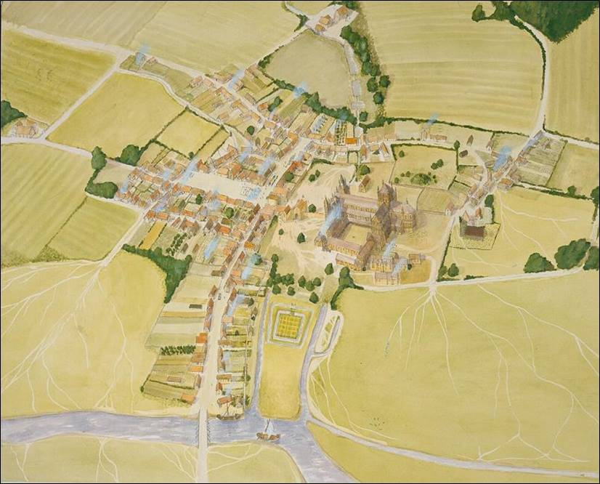

**JUNE**

**Coffee Morning at St Michael’s**

Our next Summer Coffee Morning at St Michael’s takes place on **Wednesday 5th June from 10.30am to midday**. Do come along for lovely cakes, refreshments, books, a tombola, a raffle and for a chat. Money raised goes to Women’s Refuge.

**Bible Study at Christ Church**

The monthly Bible Study for all three churches will meet at Christ Church on **Wednesday 5th June from 2.00pm to 4.00pm.** Please do come along.

**Sunday 9th June**

**Christ Church**

10.00am – Morning Worship

3.00pm – Afternoon Holy Communion

**St Andrew’s**

10.30am – Holy Communion

**St Michael’s**

5.00pm – Evening Prayer

**Coffee Morning at St Andrew’s**

Our next Coffee Morning at St Andrew’s takes place on **Wednesday 12th June from 10.30am to 12.30pm**. Do come along for lovely cakes, refreshments and for a chat.

**PCC at St Andrew’s**

The next PCC Meeting for St Andrew’s is on **Thursday 13th June at 7.30pm** at St Andrew’s. Please let a PCC member know if there is anything you would like discussed.

**Coffee Connect at Christ Church**

Coffee Connect meets on **Friday 14th June from 2.00 to 4.00pm** at Christ Church. Do come along to meet other people for a chat and enjoy homemade cakes and biscuits.

**Prayer Breakfast at Christ Church**

The next Prayer Breakfast meets on **Saturday 15th June from 9.00am** for prayer followed by breakfast. Those who would like to help with church cleaning will be meeting from 8.15am. All welcome.

**Sunday 16th June**

**St Michael’s**

9.00am – Morning Prayer

**Christ Church**

10.00am – Holy Communion

**St Andrew’s**

10.30am – Morning Worship

**Sunday 23rd June**

**Christ Church**

10.00am – Morning Worship

6.30pm – Healing Communion

**St Andrew’s**

10.30am – Morning Worship

**St Michael’s**

5.00pm – Evening Prayer

**Coffee Connect at Christ Church**

Coffee Connect meets on **Friday 28th June from 2.00 to 4.00pm** at Christ Church. Do come along to meet other people for a chat and enjoy homemade cakes and biscuits.

**Men’s Breakfast at Christ Church**

Men’s Breakfast next takes place on **Saturday 29th June at 8.30am**. Please let Alan Baker know if you would like to attend. And there is a rumour, ladies are also invited.

**Sunday 30th June 2024**

**Christ Church**

10.00am – Morning Worship

**St Andrew’s**

10.30am – Morning Worship

**St Michael’s and Songs of Praise**

6.00pm – Songs of Praise followed by refreshments

This year’s St Michael’s event for all three churches. All welcome.

**JULY**

**Coffee Morning at St Michael’s**

Coffee Morning at St Michael’s takes place on **Wednesday 6th July from 10.30am to midday**. As in June, do come along for lovely cakes, refreshments, books, a tombola, a raffle and for a chat. Money raised goes to Women’s Refuge.

**Sunday 7th July 2024**

**St Michael’s**

9.00am – Holy Communion

**Christ Church**

10.00am – Holy Communion

**St Andrew’s**

10.30am – Family Service

**Tea and Entertainment at St Andrew’s**

This year, St Andrew’s invite all three churches to an occasion of entertainment and a buffet tea on **Saturday 13th July at 4.00pm.** All welcome.

Let us continue to pray for our world and for one another as we look to God for our hope, our joy and our peace here and everywhere.

Yours in Christ. ***Sarah***

[sarahcgower@btinternet.com](mailto:sarahcgower@btinternet.com) 01733 394411 **(30)**